**SNA Assignment 2 Report**

Subhashis Suara

UCSE19012

**Parameters**

N = 1000

k = 4

p = 0.005

S = N - 1

I = 1

R = 0

beta = 0.6

gamma = 0.05

mu = 0.2

lambda = 0.4

number_of_days = 180

**SI Model**

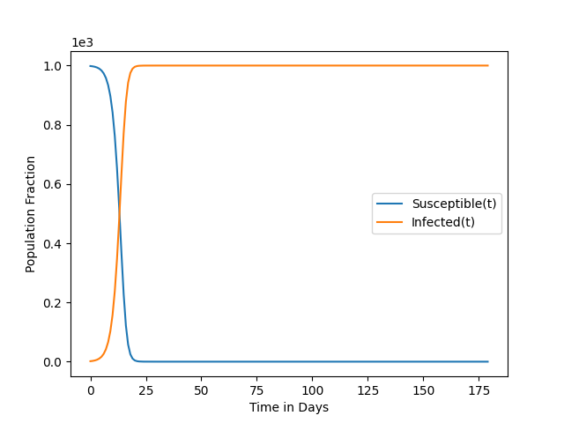

**SIS Model**

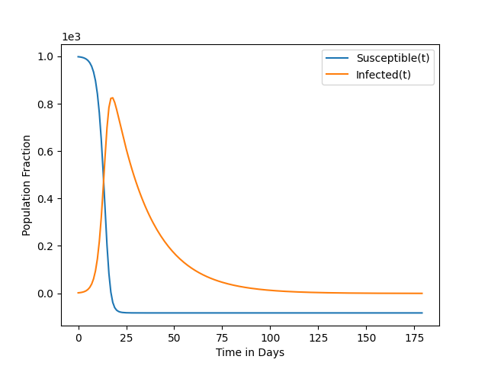

**SIR Model**

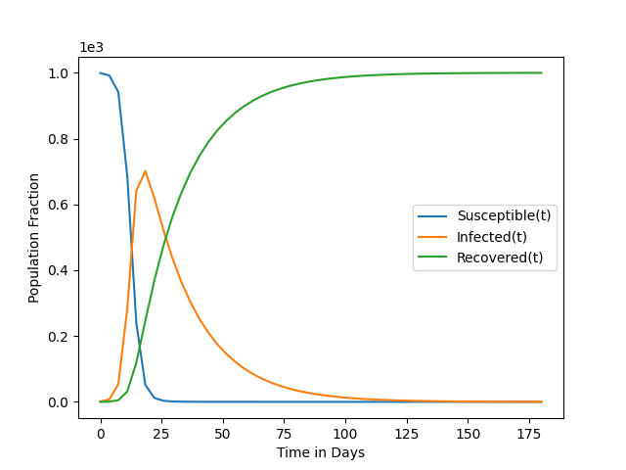

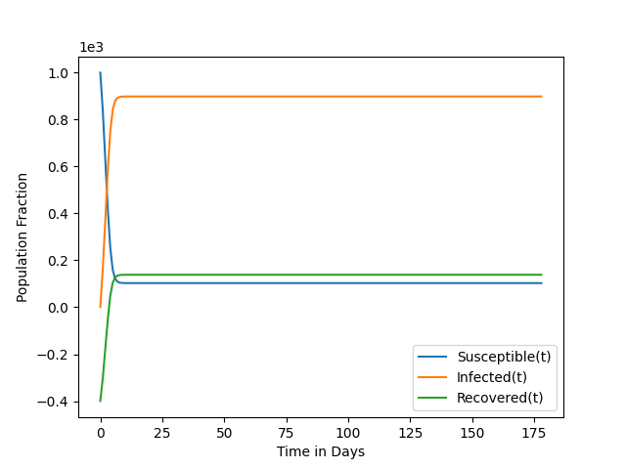**SIRS Model**